Public Service Commission
Electronic Interconnection Agreement Filing Initiative
Procedures and Guidelines

Revised 1/24/2006

Introduction:

The Public Service Commission has implemented a Web-based application for submitting electronic interconnection agreement filings, which is intended to streamline the filing and review process. Please be aware that a paper copy of your filing is still required to be filed with the Commission unless directed otherwise, or until such time as Kentucky statutes are revised to allow acceptance of electronic documents as the official record. Complete instructions on using this e-filing application will be discussed further in this document. First, we would like to address some preliminary information regarding notification procedures and electronic document formats.

Web Browser Compatibility / System Requirements and Settings:

This application has been designed to work with Microsoft Internet Explorer, versions 5.5 and 6.0 (with service pack 1). Netscape browsers may not function properly with this application and PSC support for the Netscape product is limited. Therefore, filers are advised to use one of the recommended Microsoft Internet Explorer versions. The minimum recommended computer configuration for this application is a Pentium II processor with 256 megabytes of ram. However, better performance may result from a faster processor and 512 megabytes of ram, depending on the size of documents to be transferred.

The following steps should be taken to ensure correct web browser functionality for executing the E-Filing application:

1. Open your Internet Explorer browser.
Click “Tools” from the top menu bar.
Choose “Internet Options” from the drop-down list.

- Choose the “General” tab.
Click the “Settings” button in the “Temporary Internet Files” section.
Check the box for “Every visit to the page” under the heading of “Check for newer versions of stored pages”.
- Choose the “Security” tab.
Click the button in the lower right corner of the Internet Options window labeled “Default Level”.
(If this setting is already in effect, the “Default Level” button will be disabled.)

- Disable any “Pop-up Blocker” software you may have installed on your computer. This should be controlled by an icon in the “Task Bar” at the bottom of your screen, either by double-clicking or right-clicking on the icon to access the “properties” of the Pop-Up Blocker software.

Notification procedures:

Parties participating in the electronic interconnection agreement filing process, must contact the Commission’s Executive Director in writing, on company letterhead and provide the following information: contact name and e-mail address of the person responsible for interconnection agreement filings; tariffed name of the company as filed with the Commission, mailing address, phone and fax numbers.

Upon receipt of your letter, the designated contact person will receive via e-mail, an account/user name and password, to be used for purposes of submitting electronic interconnection agreement filings. Please note that for security purposes, the account name assigned for electronic interconnection agreement filings will not be the same account name which may have been issued for other electronic filing processes, such as filing of annual report information.

In the event that a password becomes corrupted, lost or otherwise compromised, the method of re-assignment of passwords will be as follows: The party will notify the PSC via telephone at (502) 564-3940 or e-mail at pscfilings@ky.gov. PSC staff will cause a new password to be generated, then notify the party via e-mail, at the e-mail address on record. As a security measure, passwords will not be transmitted by telephone.

For questions or comments regarding use of this system, please contact the PSC at (502) 564-3940 (e-mail: pscfilings@ky.gov).

Document format:

Electronically filed interconnection agreements must be of Adobe Acrobat portable document format (PDF) and should be searchable. This can be accomplished by one of the two following methods: Installation of “Adobe Acrobat” software enables MS Word or WordPerfect documents to be ‘printed’ to ‘PDF’ format, creating a searchable output document. As an alternative, scanned documents may be converted to searchable ‘PDF’ by processing the scanned images through ‘Adobe Acrobat’ software, which converts the image contents to a searchable ‘PDF’ formatted document.

All “PDF” files should be “optimized” for viewing over the Internet. When a non-optimized ‘pdf’ document is accessed via the Internet, the browser attempts to download the entire document before displaying any of the text. For large documents or slow Internet connections, this can result in an extremely long wait period before the document will open. To address this performance issue, documents should be “optimized” for efficient downloading. When optimized, the browser will start displaying the first page as it is downloaded, allowing the user to begin reading the document shortly after the download starts, while the remainder of the document finishes downloading in the background. See the companion document titled “Optimizing PDF Documents” for complete instructions on the optimization process.

As a research aid, parties should include “bookmarks” at significant locations within interconnection agreement documents. It is recommended that each primary section within a document be bookmarked for easy access. Creation of “bookmarks”, are a feature of the Adobe Acrobat software and may be created with very little effort on the part of the preparer.

Parties filing an electronic interconnection agreement of extremely large size not conducive to electronic transfer, may, with the permission of the Commission, deliver those documents on CD. However, an accompanying electronic filing must be submitted containing a reference within a cover letter document to the fact that a CD was delivered.

Enforced limitations on electronic document filings are as follows:

Maximum individual document size = 30 megabytes.
Note: Individual documents exceeding 30 megabytes should be broken into smaller units and named accordingly (Part 1, Part 2, etc.)

Connecting to the PSC Electronic Interconnection Agreement Filing System

Parties will connect to the PSC Electronic Filing Center through the Commission’s home page at http://psc.ky.gov/ . Choose the link for “Industry Specific Info” / “Telecom”. Go to the “Interconnection Agreements” link, then follow the link labeled “Submit Electronic Interconnection Agreements”, which will connect the user to the PSC Web Portal. Please refer to the examples below.

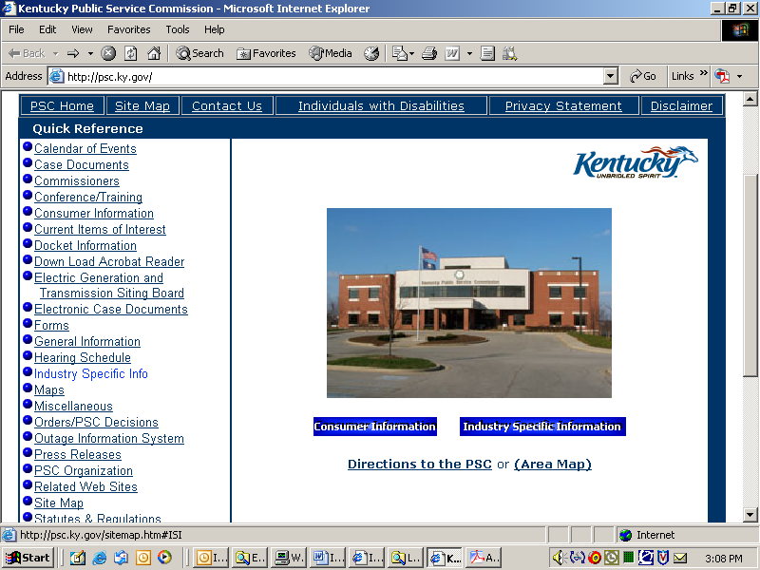

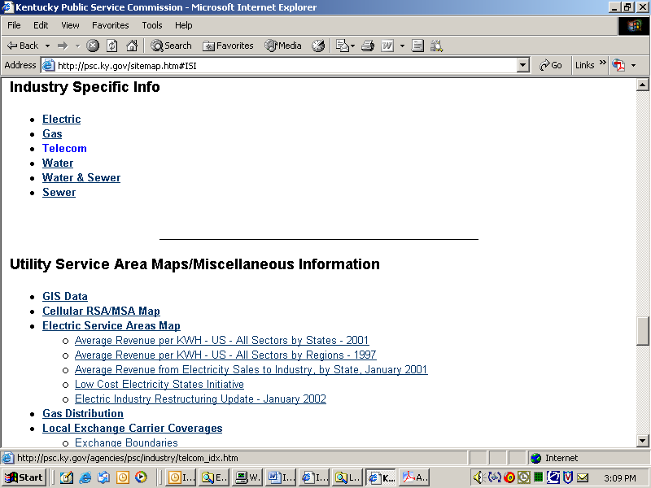

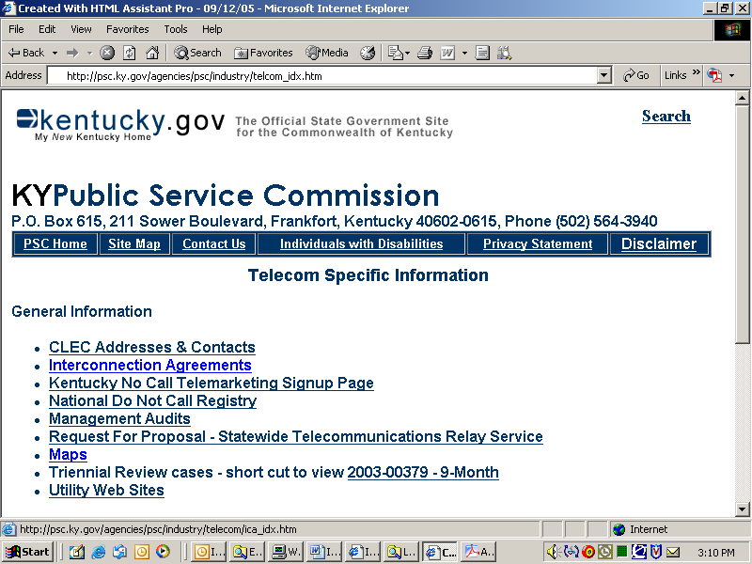

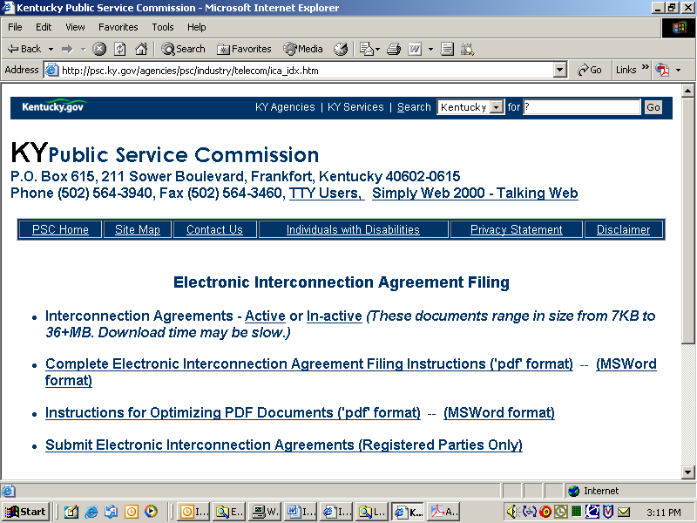

You will now be connected to the PSC E-Filing Portal, the primary point of access for most Commission Information, which is acquired by automated systems. This document will focus on submitting electronic interconnection agreement filings, however, you will see from the portal menu that additional Utility and Docket related information may be accessed from this resource.

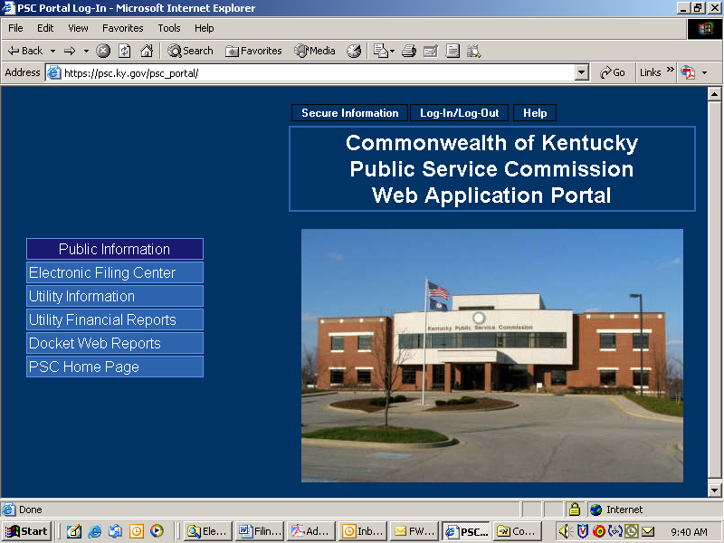

Document Naming Conventions:

The following general document naming conventions should be followed. Proposed deviations from these conventions should be brought to the attention of the PSC for consideration, as to adding them to our published standards. Document names must not contain spaces or any special characters, other than an “underscore”, therefore, we suggest using the “underscore” character in lieu of a space character within a document name. Use of special characters such as “&” in document names will cause the upload process to fail.

The following general naming conventions should be followed and include the following parts:

- The name of the document should reflect the name of the company affected by the agreement.
- Date on which the document was filed, formatted as mmddyy.
- Document name extension (.pdf).

Example: SprintCom_012006.pdf

In addition to the primary tariff documents to be filed, each filing must be accompanied by one additional document named “Read1st.pdf”. This document should contain any information such as may typically be included in a filing cover letter, including reference to any materials not included in the electronic filing, along with a statement attesting that the electronically filed documents are a true representation of the original documents to be filed with the Commission.

Submitting Electronic Interconnection Agreements:

In order for a party to submit electronic interconnection agreement filings, the filer must obtain an account ID and password, using the procedures discussed above in the “Notification Procedures” section. After obtaining your electronic interconnection agreement filing account and password, please proceed using the following instructions:

Connect to the PSC Electronic Filing Center as described in the section titled “Connecting to the PSC Electronic Interconnection Agreement Filing System”, which directs you to the PSC web portal pictured below.

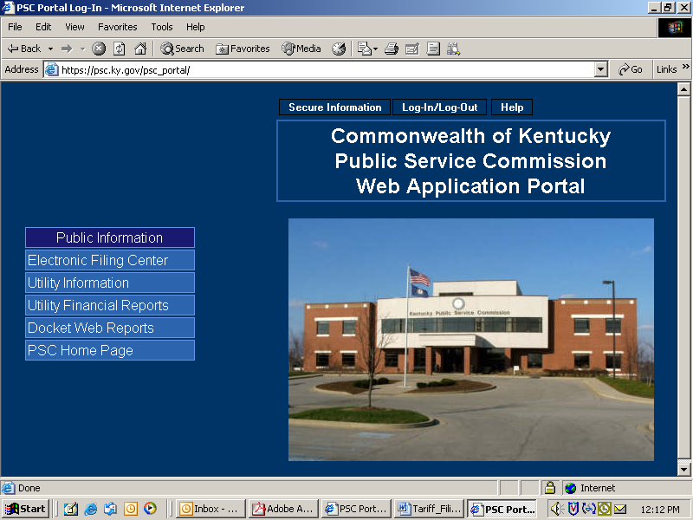

Click the “Log-in (Authorized Personnel Only)” selection on the Web Portal menu bar as in the example below:

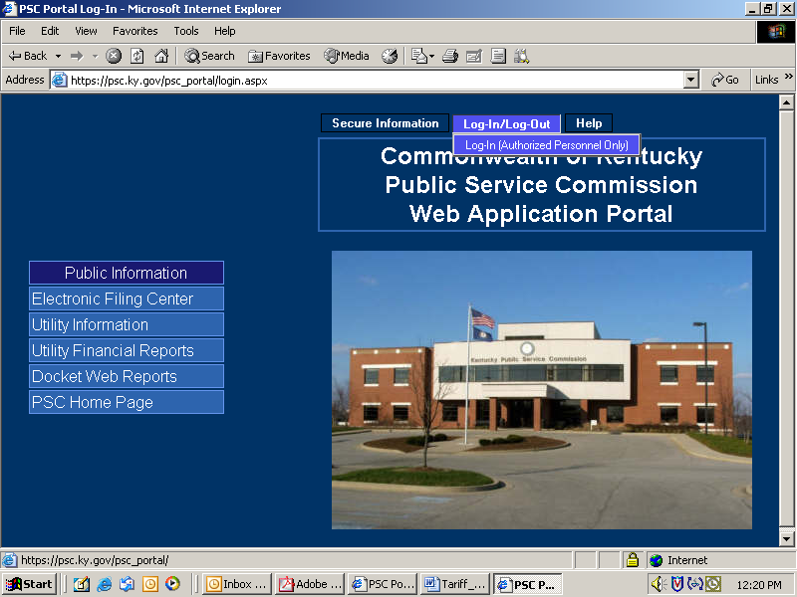

You will receive the following login window:

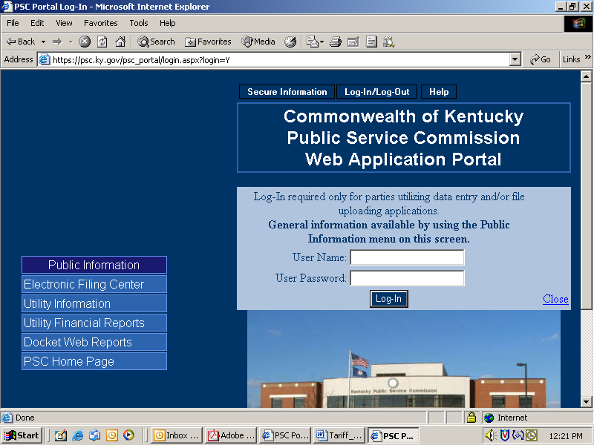

Enter your assigned User Name and Password in the spaces provided. Passwords are case sensitive and must be entered exactly as they appear in your notification e-mail. If you decide not to log in, please click the “Close” link in the lower right corner of the login window.

Upon a successful login, choose the “ICA” selection from the “Secure Information” menu. See example below:

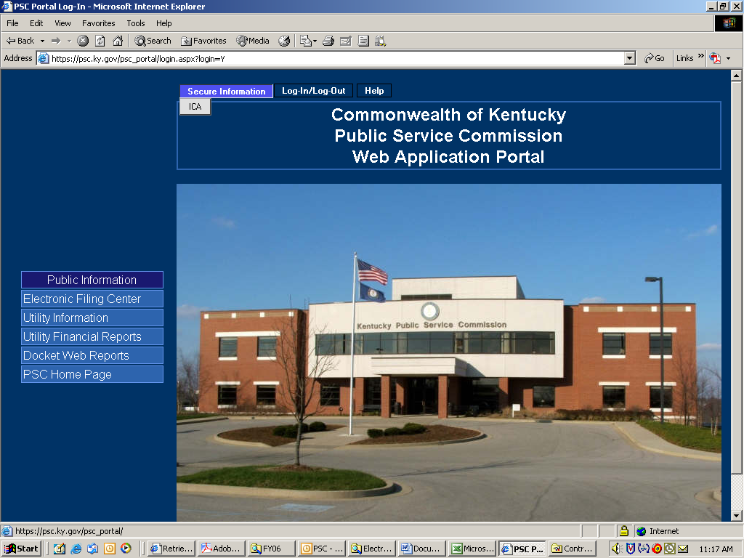

The “ICA” menu selection will place you at the “Electronic Filing Center” web page displayed below. Proceed to submit electronic interconnection agreement documents by choosing the “Upload Files” menu selection. See example below:

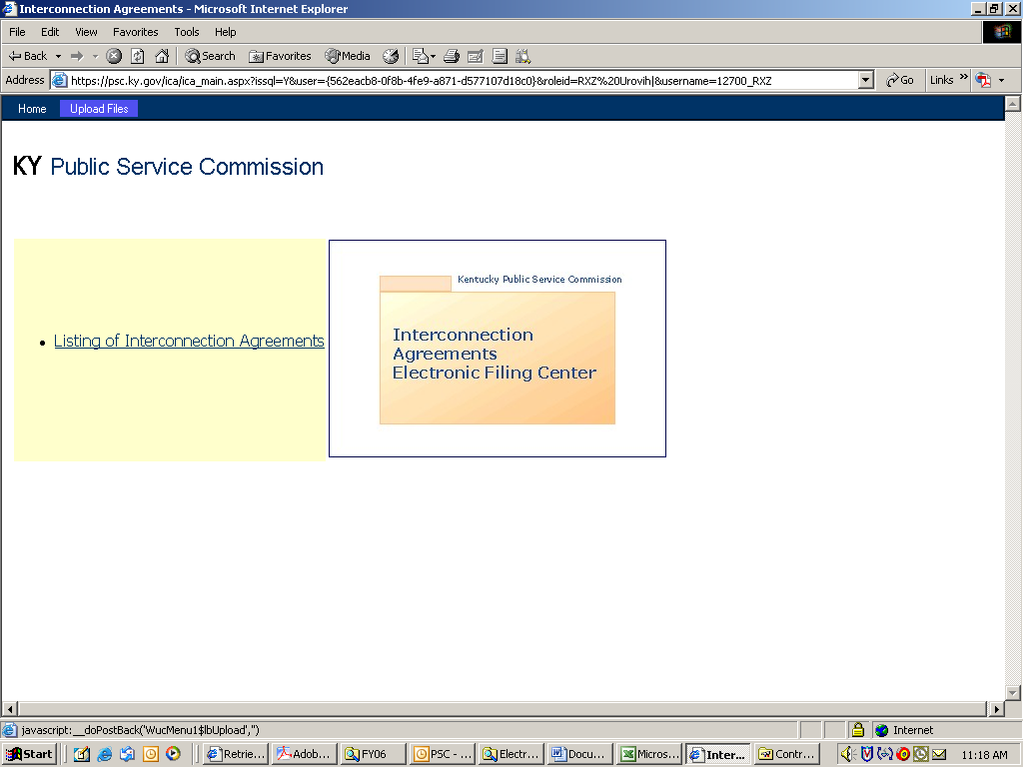

After choosing “Upload Files”, you will be presented with the following window:

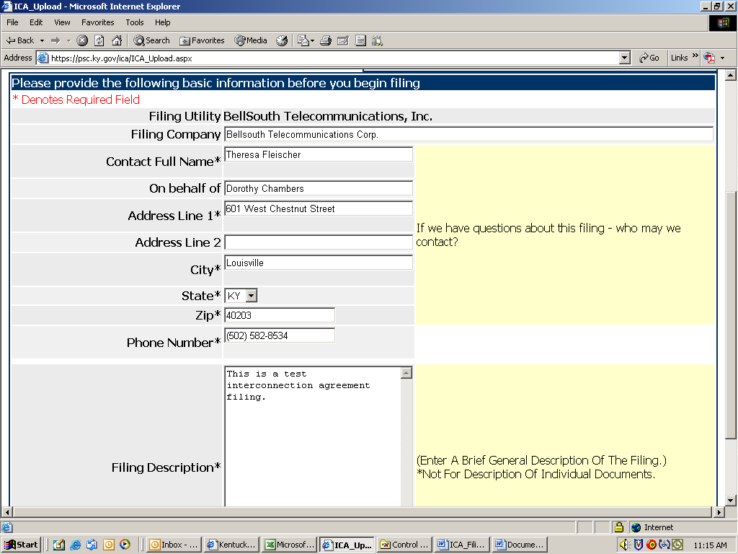

This window will be pre-loaded with selected information based on your filing ID. You may change any information as necessary and proceed to enter the remaining required fields. Following is a brief explanation of each data entry box:

Filing Company: Used if the filing is being done by an organization acting on behalf of a Utility, such as a Law Office filing for a Utilility Company.
Contact Name: Enter the name of the individual conducting the filing session.
On behalf of: Denotes that a filing was conducted on behalf of someone else, as with an attorney or consultant filing on behalf of a utility company executive.
Filer’s Company / Address: Name and address of the filing entity. May be different from the company associated with the filing ID, as with a law firm or consultant filing for a utility.
Phone Number: Enter as (555) 555-5555
Filing Description: Enter a brief general description of the filing.

Click the “Continue” button to proceed to the next window.

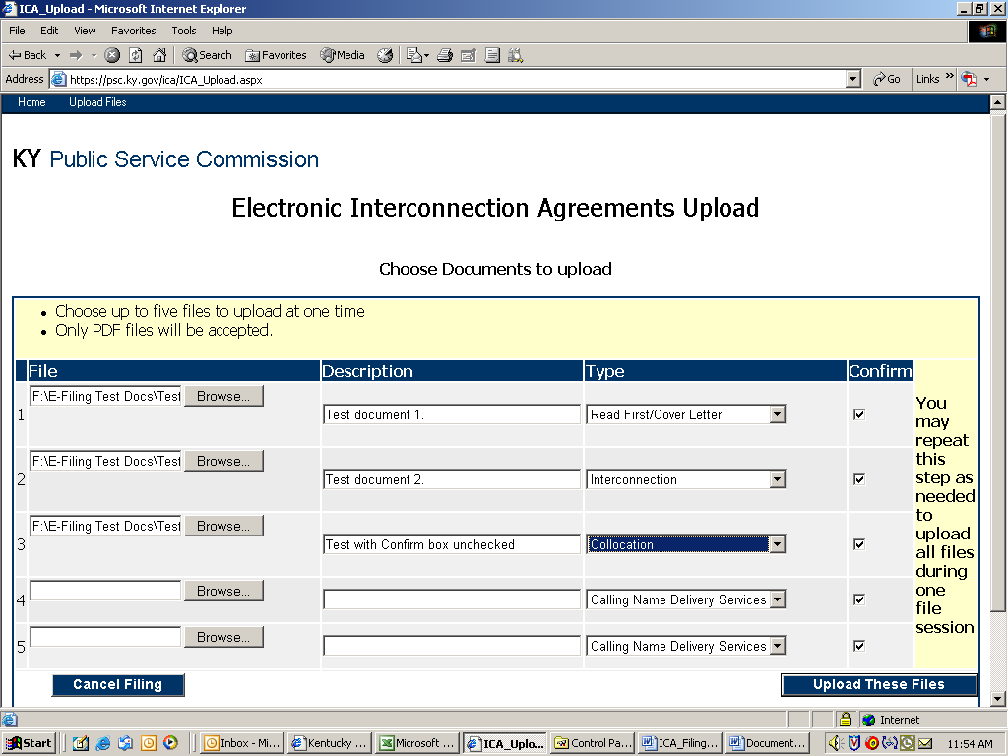

This window is used to select the individual documents to be uploaded. You may select up to five documents per window. You must also enter a brief description of each document in the space provided, along with an appropriate choice from the drop-down list, as to the type of document being submitted.

If you select a document and then wish not to have it uploaded, simply uncheck the corresponding box to the right of the entry, in the column labeled “Confirm”. Only documents with the “confirm” box checked will be uploaded.

When you have selected up to five documents, you must press the button at lower right labeled “Upload These Files”. You will then be presented with a fresh window where you may proceed to upload an additional batch of up to five documents. Remember - You must press the “Upload These Files” button in order to process each batch of documents.

If you wish to cancel your filing session, simply press the “Cancel” button located at the lower left of the filing window.
After uploading each batch of documents, your window will be refreshed to look similar to the example below, with five blank spaces to upload additional documents.

There is a section at bottom containing a list of all documents which have been previously uploaded successfully during the current session.

Conditions resulting in documents not being uploaded will cause an informational window to appear, referring you to a section in the middle of the window, labeled “Known Errors”, which is intended to include an entry for each instance of failure.

Remember to press “Upload These Files” to process each additional batch of documents.

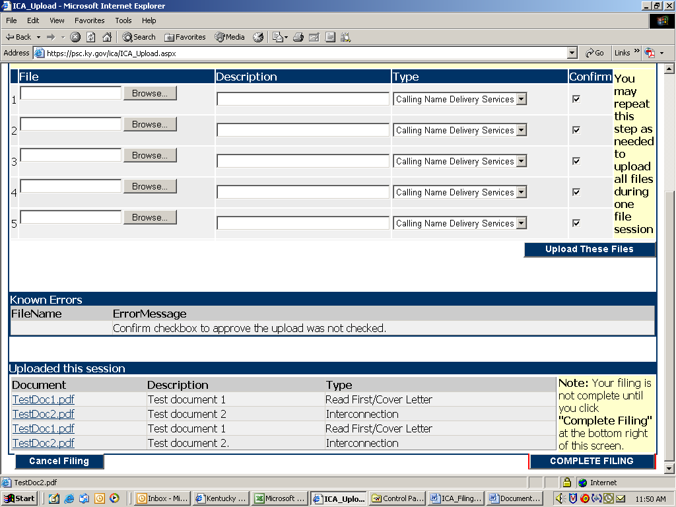

When finished uploading all required interconnection agreement documents, you must press the button located at the lower right corner of your window labeled “Complete Filing”. Failure to press the “Complete Filing” button will cause all uploaded documents to be removed from our system, without being processed.

After pressing the “Complete Filing” button, you will be presented with a confirmation window containing a list of all documents included in the filing session, as in the sample window below.

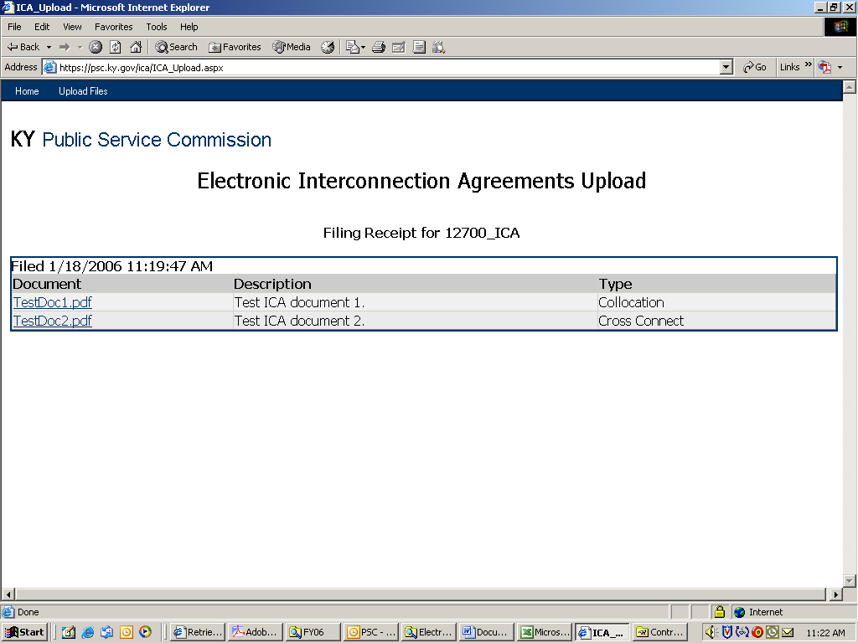

You should print and retain this confirmation information as proof of your submission. A confirmation e-mail will also be automatically generated to the e-mail address associated with the filing ID which was used to log into the PSC portal.

Important: Please print this confirmation screen or your confirmation e-mail message and attach it to the front of the required paper copy. The printed confirmation will inform our staff that the documents are associated with a previously electronically filed interconnection agreement.

Patience is required when using this system via a “dial-up” modem connection or when uploading extremely large documents. Dial-up users should be aware that a typical “56K” modem connection usually yields no more than a 40,000 bits per second (4,000 characters per second) transfer rate. Therefore, uploading documents of one megabyte (1 million characters) in size could take nearly 5 minutes to complete. Also, a poor quality phone line may result in failure to complete the document transfer process.

This electronic filing system works best using a high-speed Internet connection such as DSL, cable modem or T1.

